Team IR Project Questions and Edits

Player Class

* Needs to implement Actor
* Needs a PlayerStat object to be instantiated so we can use an updateMessage method
* Needs a Clock object to be instantiated so we can use the getTicks method
* Needs an NFLTeam object so that we can pass an NFLPlayer object parameter to the updateMessage method. We're already using the variable positionWithBall to say who has the ball. We could use the method in the NFLTeam Class getPlayerByPos(String pos) to return an NFLPlayer object.
* Need to add a try/catch block to every call of updateMessage b/c updateMessage throws an exception. Maybe something like this?:

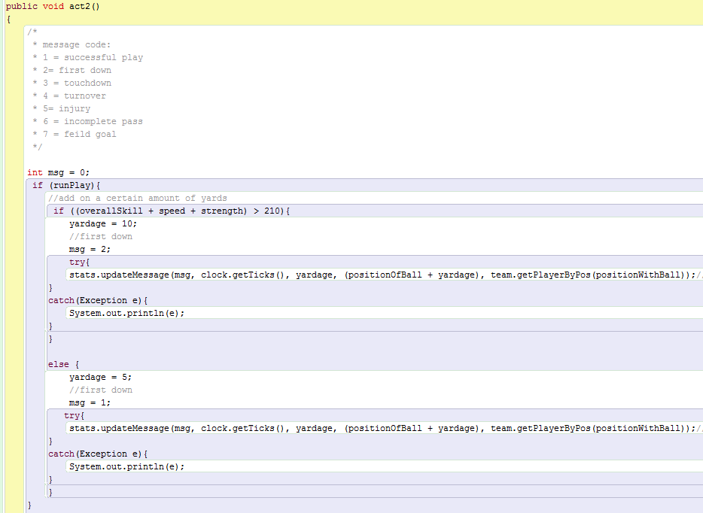

NFLTeam

* Needs to implement Actor
* Are we merging Player and NFLPlayer or are they remaining separate? NFLTeam is heavily dependent on NFLPlayer. It would be a lot of work to merge them and Player is already pretty big as it is. Controller Class definitely needs to know this.
* If we are still using NFLPlayer then it also needs to implement Actor.

Controller

* Need to move the instantiated private variables outside the constructor.
* Does the Randomizer object or the Statistic object need to be in the actors list? There's no act method in either of them
* Need to make actors into a LinkedList
* actors need to use addAll() when adding ArrayLists. Maybe something like this: 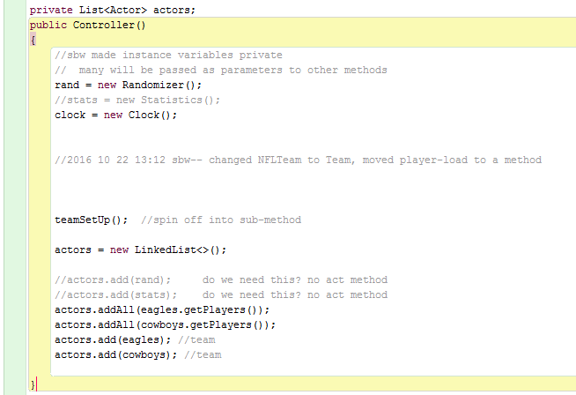

Statistics

* Class is abstract - needs subclasses to be useful to classes that call it (Controller)
* I commented out the spreadsheet library import and the spreadsheet read method
* Controller was looking for a Statistic'S' object... Statistic or Statistics?
* The ***Message class*** parameters - int messageCode, Player or NFLPlayer, int tick, int yardage, int ballPosition. ==> Statistics Group needs to know if it's Player or NFLPlayer
* The ***PlayerStat*** parameters for updateMessage - int messageCode, int tick, int yardage, int ballPosition, Player or NFLPlayer?